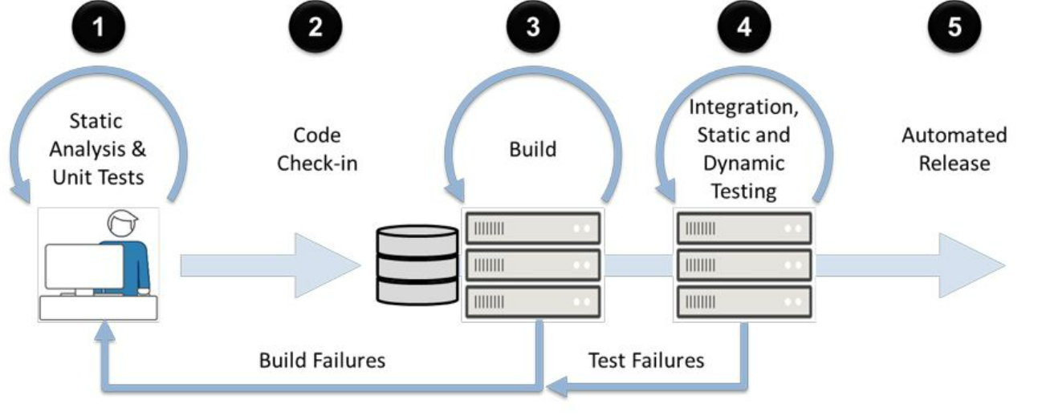

1️⃣ What is Code Quality?
✅ Simple Definition
Code Quality refers to how clean, readable, maintainable, efficient, and error-free a codebase is.
Good code quality means:
- Easy to read
- Easy to modify
- Fewer bugs
- Better performance
- Long-term maintainability

🧠 Real-World Analogy
Writing code without quality rules is like building a house without a blueprint.

🔍 Key Code Quality Parameters
Parameter | Meaning
Readability | Easy to understand
Maintainability | Easy to change
Reusability | Can be reused
Performance | Efficient execution
Security | No risky patterns

2️⃣ What is Static Code Analysis?
✅ Definition
Static Code Analysis is the process of analyzing source code without executing the program.
📌 It checks code structure, patterns, and rules, not runtime behavior.

🔄 Static vs Dynamic Analysis
Static Analysis | Dynamic Analysis
Code not executed | Code executed
Finds design issues | Finds runtime bugs
Early detection | Late detection
PMD, Checkstyle | JUnit, Selenium

🧠 Memory Line
Static analysis = Code inspection at rest

3️⃣ What is PMD?
✅ Definition
PMD is a static code analysis tool for Java that detects common programming flaws, bad practices, and code smells.
PMD helps identify:
- Unused variables
- Empty catch blocks
- Duplicate code
- Overly complex methods
- Poor naming conventions

🔧 Why PMD is Needed
🚨 Problems without PMD:
- Code smells grow silently
- Technical debt increases
- Bugs appear late
- Review becomes manual
✅ PMD solves:
- Automated quality checks
- Enforced coding standards
- Early issue detection

4️⃣ How PMD Works (Internally)
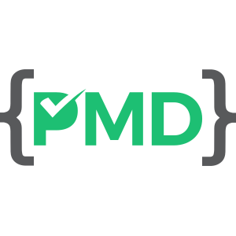
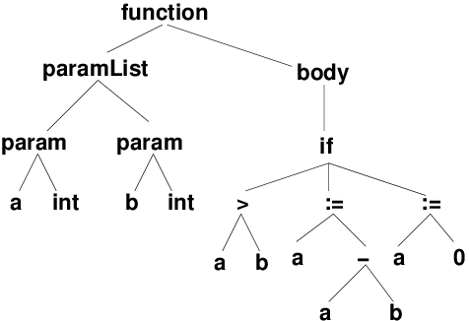
🔄 PMD Process Flow
- Reads Java source code
- Builds AST (Abstract Syntax Tree)
- Applies rules
- Generates report (HTML / XML / console)

5️⃣ What are PMD Rules?
✅ Definition
PMD Rules are predefined checks that detect specific coding problems.
Each rule:
- Targets a bad coding practice
- Produces a warning or error
- Improves code quality

📂 Major PMD Rule Categories
Rule Category | Purpose
Best Practices | General clean coding
Code Style | Formatting & naming
Design | Architecture issues
Error Prone | Bug-prone code
Performance | Inefficient logic
Security | Risky code patterns
Documentation | Missing comments

🧪 Example PMD Rule Violation
❌ Bad Code
public void calculate() {
int x = 10; // unused variable
}
PMD Warning:
Avoid unused local variables
✅ Fixed Code
public void calculate() {
System.out.println("Calculation done");
}

6️⃣ What is a PMD Ruleset?
✅ Definition
A Ruleset is a collection of PMD rules applied together.
📌 Rulesets are written in XML.

🧠 Memory Tip
Rule = One check | Ruleset = Group of checks

📄 Sample PMD Ruleset XML
<?xml version="1.0"?>
<ruleset name="Custom Java Rules">
<description>Company coding standards</description>

<rule ref="category/java/bestpractices.xml"/>
<rule ref="category/java/errorprone.xml"/>
<rule ref="category/java/performance.xml"/>
</ruleset>

🎯 Why Custom Rulesets?
- Company standards
- Project-specific needs
- Remove unwanted rules
- Control strictness

7️⃣ Common PMD Rules (Important for Interviews)
Rule | Meaning
UnusedLocalVariable | Variable never used
EmptyCatchBlock | Catch block is empty
AvoidDuplicateLiterals | Repeated literals
CyclomaticComplexity | Method too complex
AvoidPrintStackTrace | Bad error handling
ExcessiveMethodLength | Method too long

8️⃣ PMD Configuration (Very Important 🔥)
PMD can be configured in:
- Maven
- Gradle
- IDE (IntelliJ / Eclipse)

🟢 PMD Configuration with Maven
Step 1: Add Plugin in pom.xml
<plugin>
<groupId>org.apache.maven.plugins</groupId>
<artifactId>maven-pmd-plugin</artifactId>
<version>3.21.0</version>
<configuration>
<rulesets>
<ruleset>/rulesets/java/quickstart.xml</ruleset>
</rulesets>
</configuration>
</plugin>
Step 2: Run PMD
mvn pmd:check

🟢 PMD Configuration with Gradle
apply plugin: 'pmd'

pmd {
ruleSets = []
ruleSetFiles = files("config/pmd/ruleset.xml")
}
Run:
gradle pmdMain

🟢 PMD in IntelliJ IDEA
Steps:
- Install PMD Plugin
- Settings → Tools → PMD
- Select ruleset XML
- Analyze → Inspect Code

9️⃣ PMD Reports
PMD generates:
- Console output
- HTML reports
- XML reports (CI/CD)
📌 Used in:
- Jenkins
- Azure DevOps
- GitHub Actions

🔟 Where PMD is Used in Real Projects
Area | Usage
Enterprise apps | Mandatory quality gate
CI/CD pipelines | Fail build on violations
Code reviews | Automated review
Legacy projects | Cleanup support

1️⃣1️⃣ Interview One-Liner Answers
Q: What is PMD?
👉 PMD is a static code analysis tool that detects bad coding practices and improves code quality.
Q: Difference between PMD and JUnit?
👉 PMD checks code structure, JUnit checks runtime behavior.

🧠 Final Memory Summary
🔹 Code Quality = Maintainable code
🔹 Static Analysis = No execution
🔹 PMD = Automated code police
🔹 Ruleset = Quality policy

